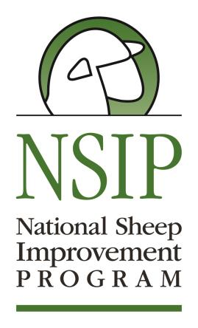
Eastern NSIP Sale Consignment Form
Entry Deadline: June 1, 2018
Entry Fee: $35 per entry
Make Checks Payable to: National Sheep Improvement Program
Send Entry form, sale agreement and payment to:
NSIP PO Box 1258 Ames, IA 50014

Farm/Ranch Name: ____________________________________________________________
Breeder Name: ________________________________________________________________ Address:______________________________________________________________________City, State, Zip:_________________________________________________________________ Email: ______________________________________ Phone: ___________________________
Total Number of Entries: ________________________________________________________
Consignors Signature:___________________________________________________________
By signing this form, consignors agree to all terms and conditions of the sale. Please fill out the information below for all entries. In the pedigree, use the format you’d like printed in the sale catalog. You can make as many copies of the table as necessary for all your consignments. If you would like pictures included, they will be in black and white and must be emailed to Rusty Burgett by July 1. If you have any questions, contact Rusty Burgett by email info@nsip.org or by phone at 515-708-8850
NSIP ID Number: |  |  |  |  | Animal ID
Eartag Number:
Sex:
Date of Birth
EBVS: Include any/all that apply
BWT | WWT | MWWT | PWWT | PEMD |  | PFAT | NLB | NLW | WFEC | PFEC | Index:________ | Other:_________
Comments:

NSIP ID Number: |  |  |  |  | Animal ID
Eartag Number:
Sex:
Date of Birth
EBVS: Include any/all that apply
BWT | WWT | MWWT | PWWT | PEMD |  | PFAT | NLB | NLW | WFEC | PFEC | Index:________ | Other:_________
Comments:

NSIP ID Number: |  |  |  |  | Animal ID
Eartag Number:
Sex:
Date of Birth
EBVS: Include any/all that apply
BWT | WWT | MWWT | PWWT | PEMD |  | PFAT | NLB | NLW | WFEC | PFEC | Index:________ | Other:_________
Comments:

NSIP ID Number: |  |  |  |  | Animal ID
Eartag Number:
Sex:
Date of Birth
EBVS: Include any/all that apply
BWT | WWT | MWWT | PWWT | PEMD |  | PFAT | NLB | NLW | WFEC | PFEC | Index:________ | Other:_________
Comments:

NSIP ID Number: |  |  |  |  | Animal ID
Eartag Number:
Sex:
Date of Birth
EBVS: Include any/all that apply
BWT | WWT | MWWT | PWWT | PEMD |  | PFAT | NLB | NLW | WFEC | PFEC | Index:________ | Other:_________
Comments:

